**JOBSHEET 1**

**Programming Languages (Java Development Kit / JDK Installation)**



**Name**

Sherly Lutfi Azkiah Sulistyawati

**NIM**

2341720241

**Class**

1I

**Department**

Information Technology

**Study Program**

D4 Informatics Engineering

Labs Activity

**Question! (Experiment 1)**

1. Why do we have to enter the **bin** folder location from Java into the **PATH** variable?

2. What is the use of **javac** command when entered at the command prompt!

**Answer!**

1. We set the path and specify the path of the bin folder because the bin contains all binary executable files. So that you can run java commands and programs from any directory in the command prompt or terminal.

2. The javac command reads source files that contain module, package and type declarations written in the Java programming language, and compiles them into class files that run on the JVM (Java Virtual Machine).

**Question! (Experiment 2)**

1. What is the use of **javac** command in the above steps? (**javac MyFirstJava00.java**)

2. What is the use of **java** command in the above experiment? (**java MyFirstJava00)**

3. What is the use of **main** method in java programming, what is the format of **main** method?

**Answer!**

1. The javac command is use to compile java program.

2. The java command is use to run java program.

3. The Java main method is the entry point for executing a Java program. The main method can contain code to execute or call other methods. A program that does not have the main method gives an error at run time.

**Question! (Experiment 3)**

1. Change the statement **System.out.println** to be **System.out.print** at line 7 and 8, then run the program!

2. What is the difference between **System.out.println("..........");** and **System.out.print("............");?**

3. Change the statement at line 8 as the following syntax!

System.out.print("\nsaya adalah Mahasiswa Jurusan Teknologi Informasi - POLINEMA");

4. What is the use of **\n** at line 8!

5. Still at line 8, add character **//** in front of the source code!

//System.out.print("\nsaya adalah Mahasiswa Prodi Teknik Informatika");

6. Run the program and observe the result! And what is the use of character **//** ?

**Answer!**

1.

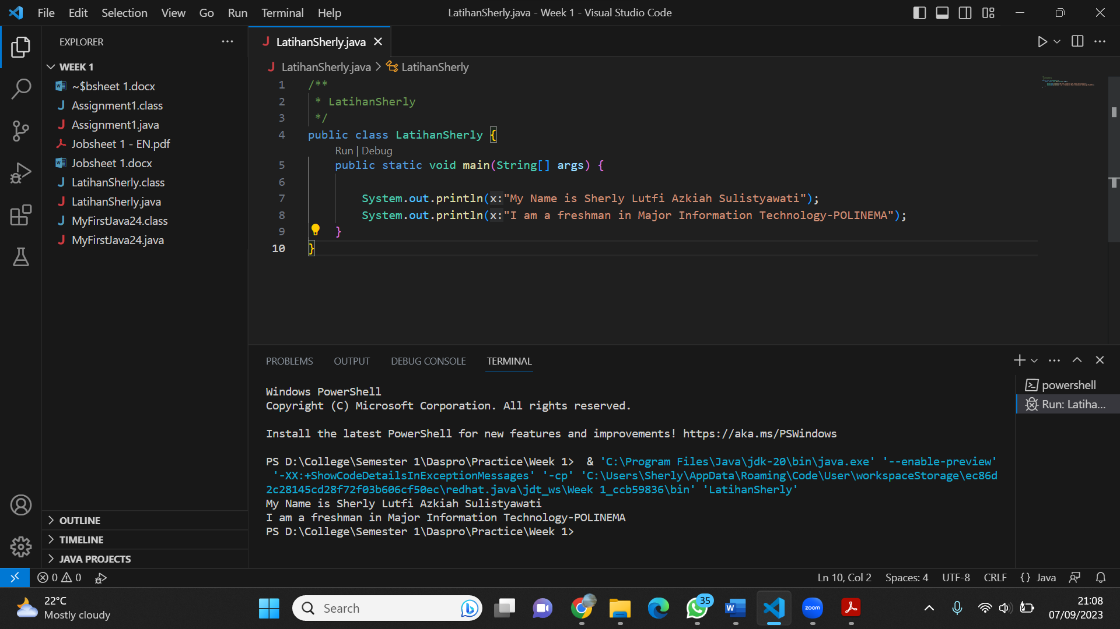

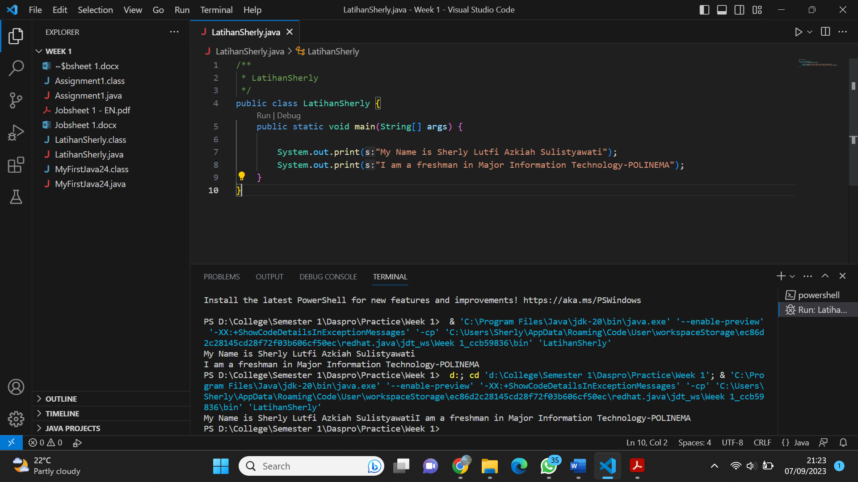

2. The difference between println and print method is that println throws the cursor to the next line after printing the desired result whereas print method keeps the cursor on the same line.

3.

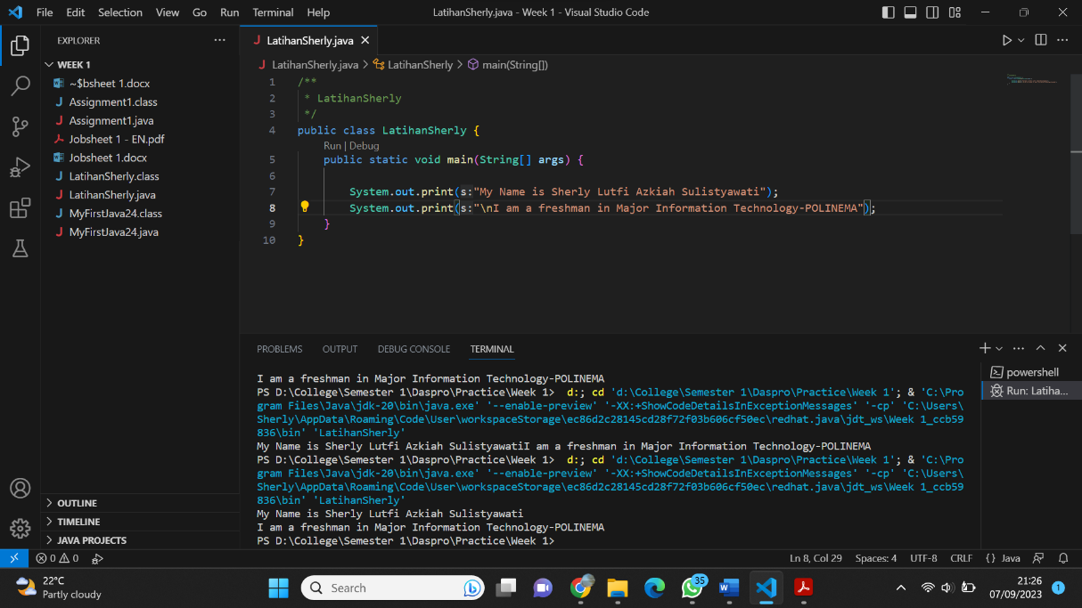

4. The newline character ( \n ) is called an escape sequence, and it forces the cursor to change its position to the beginning of the next line on the screen. This results in a new line.

5.

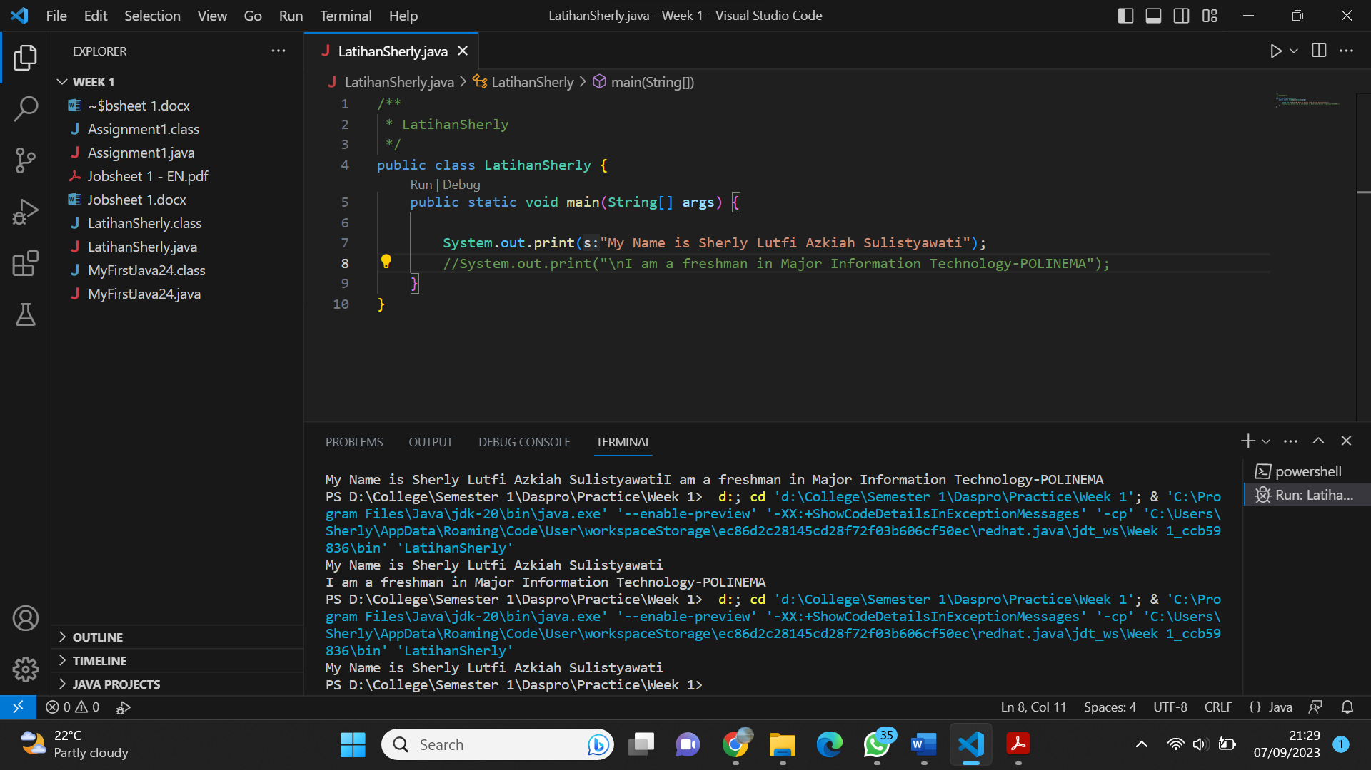

6. The two forward slashes character ( // ) is use to add comment. Any text between // and the end of the line is ignored by java (will not be executed).

**Assignment**

Create a Java program with the following output, then explain the program you have created!

